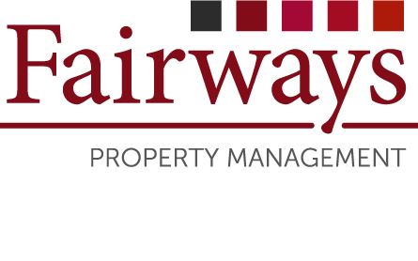
Name(s) of Property Owner(s): | 1……………………………………………………………………………..  2……………………………………………………………………………..
Address of the managed Property: | ……………………………………………………………….….………...…  ……………………………………………………………….………………
Address of Property Owner(s) if different from above: | ……………………………………………………………………..……..…  …………………………………………………………………..………..…
Contact Details: | Home Tel No: |  | …………………………………………….………
 | Mobile Tel No: |  | 1.………………………………………………….
 | Work Tel No: |  | 1.………………………………………………….
 | Email Address |  | 1.………………………………………………….
 | Mobile Tel No: |  | 2.…………………………………………….……
 | Work Tel No: |  | 2.………………………………………………….
 | Email Address |  | 2.………………………………………………….
Is the Property Tenanted? | Yes No
If yes, please give name(s) of the Tenant (s) | 1………………………………………………………………………….…..  2……………………………………………………………………….……..
Contact Details:  Please help us by providing at least one number and one email address of your tenant(s) | Mobile Tel No: | …………………………………………….………
 | Email Address | …………………………………………….………
Name & Contact Details of Letting Agent: | ………………………………………………………………………...…..…  ………………………………………Tel:…………………………………..

